
BISHOP STREET METHODIST CHURCH
...serving people in Leicester City Centre (Reg. charity 1129068)
through welcome, worship and mission.
10a Bishop Street, Town Hall Square, Leicester, LE1 6AF.
Office tel. 0116 255 4111 E-mail: office@bishopstreetchurch.org.uk
NOTICES for 25th July, 2021
Pastoral Cover: Between 25 July and 1 September, Bishop Street will be covered by Rev. Paula Hunt, superintendent minister of the Leicester Trinity Circuit. Initially, please contact your pastoral visitor. Since the Circuit will be down 3 ministers during this period, please only contact Paula in an emergency on revpaula@the-manse.net or on 0116 267 3960.

A message from Rev. Fran:
Dear Everyone,
This is to say a big thank you to everyone for your wonderful gift of the Sarah Kirby print of Bishop Street Methodist Church. I love this print and there are plenty of walls in our new manse for it to hang on. It will remind me of you all and of the terrific experiences of God’s grace and wonder that I (and Diane too) have had through this Methodist Christian community. Thank you also for the generous cheque and for your messages and thoughtful words to help send me on my way! Diane too sends her heartfelt thanks for the gracious gift of a garden token. She’s already planning how to spend it to help us settle into our new manse.

I pray that God’s blessings will continue to be with you as you take forward Christ’s mission with your new minister, Liam.

Grace and Peace, Fran

This Sunday 25th July there is no face to face Service at Bishop Street. There is a Circuit Farewell Service on 25th July at 10.30am at Mayflower Methodist Church. Only 4 attendees from each church served by Rev'ds Jenny Impey, Saidu Kanu, and Fran Rhys are allocated space to attend the service.
It will be possible to attend this service on Zoom. At 10:30am on Sunday, July 25th, all the churches are invited to join in the online Circuit Service to say Farewell to Revs Jenny Impey, Saidu Kanu and Fran Rhys, and a heartfelt “thank you” to Diana Allen and Julie Manning, who step down as Circuit Stewards. Unfortunately, there isn’t a church big enough to invite everyone to attend in person, but you are all welcome to log in and join us online.

The link to use is the usual link for Circuit Services:
https://zoom.us/j/87603771006?pwd=OTFSQ2JiL3hkWUp1NnU1b1ZiVDJudz09

Meeting ID: 876 0377 1006
Passcode: 281338

Or join us on the phone: 0208 080 6591
and be ready to enter the Meeting ID and Passcode when prompted.

August Worship
August 1st Susan Alexander This is Susan's trial service to enable her to transfer from 'on note' to 'on trial' in her training to be a local preacher. Please come and support her and give her some feedback after the service.
August 8th Richard Tinley Local preacher
August 15th Rev Tony Pick Holy Communion
August 22nd LA led by Mary Gill Climate Sunday
August 29th NO SERVICE AT BISHOP STREET. Circuit service at Wigston Magna and on Zoom. This is a Welcome service for the 2 new ministers and a deacon who are joining the circuit.

Help with leading worship on 22nd August- Climate Sunday - is welcome. Please let Mary Gill know if you would like to take part.
From 25th July until 1st September, pastoral cover will be provided for Bishop Street by the Superintendent Minister, Rev. Paula Hunt. Since three ministers will have left the Circuit, please only contact her in emergencies on revpaula@the-manse.net or on 0116 267 3960.
The Sunday morning service will be recorded and the basic video will be available on an unlisted Youtube link from late lunchtime on Sunday. If you would like to be sent the link to watch later on Sunday or in the week, please request this from Miriam (mcg9@le.ac.uk). We will also mount the link on the blog (see link below).
https://bishopstreetmethodistchurchsundaystuff.wordpress.com/
Pastoral News Dr Graham Morgan, a long-time adherent of Bishop Street and university archaeologist died quickly on Friday 9th July. The date of his funeral is August 4th at 14:30. May he rest in peace and rise in glory.
Our Arts Enabler and Administrator, Leonie DuBarry-Gurr will complete her contract with Art at the Chapel at Bishop Street Methodist Church at the end of July. We sincerely thank her for all the energy, ideas, and enthusiasm she has contributed to the church and for helping many new people visit and use the church. We are very glad that her association with the church will continue through a 'Community Interest Company' she is forming for exhibitions and concerts to book space at the church. Watch this space!
The Connexional Guidance on Covid and Property is now out (see link below)
It advises a continued, cautious phased return, taking into consideration matters such as personal vulnerability, and it recommends the wearing of masks, limiting the number of hymns sung "when permitted", facilitating ventilation, and continuing track and trace records. A Risk assessment is still necessary. We're to consider retaining the reasonable safe practices for cafes when providing or distributing food and drink, such as after a service or other events.
Nothing changes until after the 19th July and the Methodist Church will issue more advice as it is issued. Coronavirus Guidance for Property (methodist.org.uk)

Methodist News https://methodist-news.org.uk/BVI-7GL4O-84CBE9659B8B9C065V64QH29073FDBD49A318B/cr.aspx
Mid-week worship takes place on Wednesdays between 1-1.30pm. The only lunchtime service in August will be on Weds 11th August and it will be led by local preacher, Shirley Kendall.
Exhibition: The Journeys Festival International Your City project is up now in The Chapel Gallery.
This is an exhibition showcasing a selection of collages and poetry created by wonderful young people during workshops in Leicester in partnership with After18. See the exhibition from 12 to 30 July.
Church and Café Broadband – We are pleased to announce Broadband is now up and running at a healthy speed in the church and café area. Guests can login using the code from the café staff.
Display outside of BSMC for ZT ‘Honour based violence remembrance and awareness raising event’ on July 14th
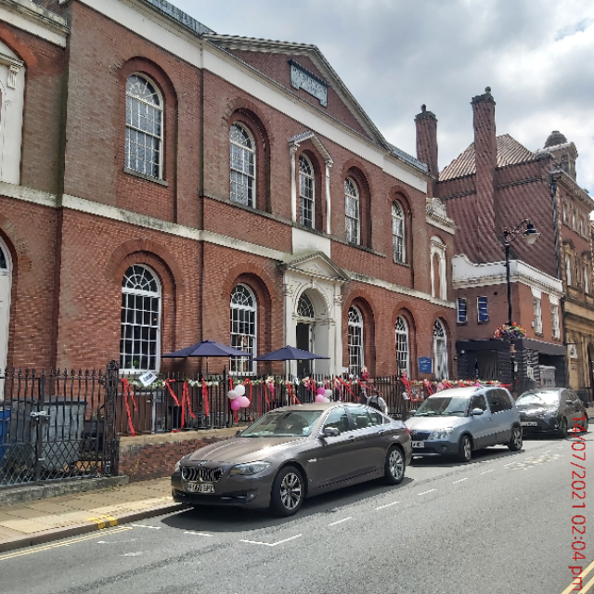
Donations Thank you for all your faithful and generous donations. Giving is at about 80% of what the Treasurer estimated would be received. Do check that your giving to the church is up to date, or consider making a small increase if possible. Envelopes are ready for collection from the church vestry. Please either send a cheque to the church’s Gift Aid Officer, Tony Moore at 46 Holmfield Road Leicester LE2 1SA, or make a BACS transfer to Bishop Street Methodist Church through our Cooperative Bank account - sort code 08-92-99 and account number 65242955. Alternatively you can go to the Church's website www.bishopstreetchurch.org.uk and look for the 'Donate' button on the Home page and donate with a debit or credit card.

